**Technology Company Layoffs (2022-2023)**

**Most recent technology layoffs and insights on industry trends**

short line

Ana Cury

February 1st 2023

# Introduction

# Massive layoffs currently shake the technology industry since mid-2022 including major businesses like Amazon, Microsoft, Google, and Wayfair. This is due to increased expenses caused by inflation, along with the massive hiring spree that occurred once the height of the pandemic was over. Companies have turned to one of the largest company expenses, the labor force, to initiate cost-cutting measures. This report will discuss visualizing current layoff trends based on months, identifying which locations are most impacted and whether IPO status affects the severity of layoffs.

**—------------------------------------------------------------------------------------------------------------------------------------**

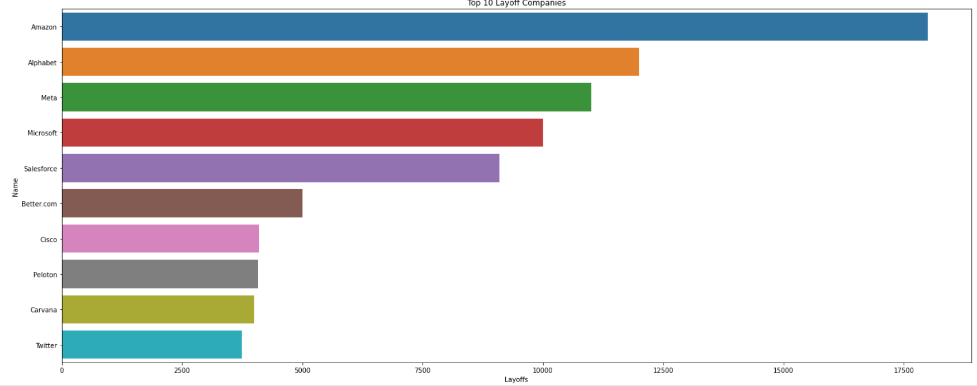

**Top 10 Companies with Highest Layoffs as shown by the graph:**

1. **Amazon**
2. **Alphabet**
3. **Meta**
4. **Microsoft**
5. **Salesforce**
6. **Better.com**
7. **Cisco**
8. **Peleton**
9. **Carvana**
10. **Twitter**

Many different factors including company size, laborforce size, industry, plant capacity, financials, and technology all affect a company's decision when laying employees off. One major trend I discovered was that public tech companies had a drastic layoff, while private ones had minor layoffs. As can be seen in this graph: Amazon, a public company, had the highest number of layoffs with around 18k. Next came Alphabet, another public company with around 12K layoffs. Out of the top ten companies with the highest layoffs, 9 of them were public while only Better.com was private with 5,000 layoffs.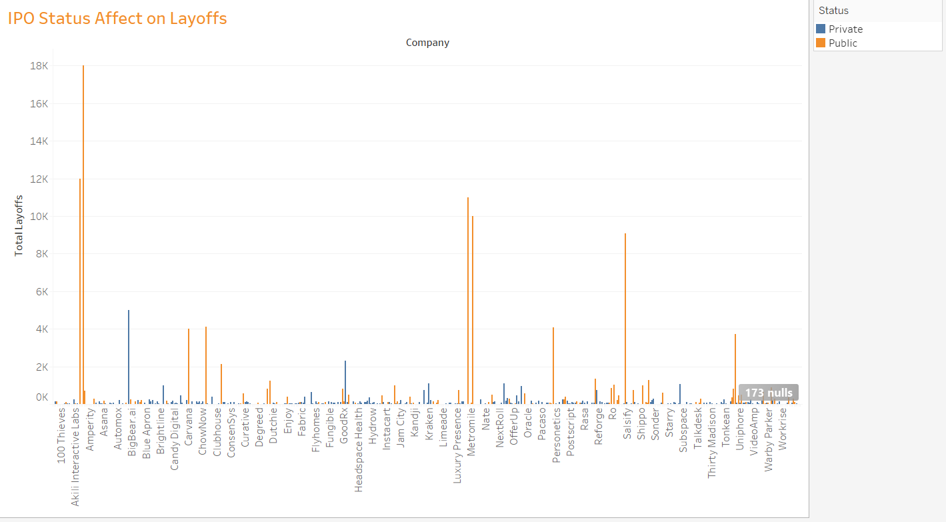

This visual shows the impacted percentage of that an industry's workforce. The industries with the bigger dimensions suffered a higher workforce percentage. While the darker colors represent a bigger total number of layoffs. While some industries like E-commerce laid off the triple amount of employees as companies in Fintech, they had such a large workforce that it didn’t impact them as much. 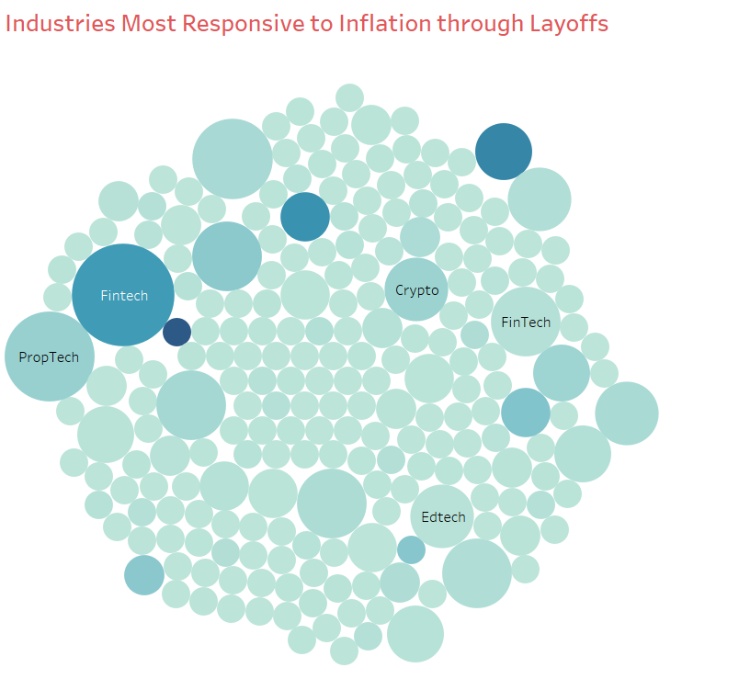

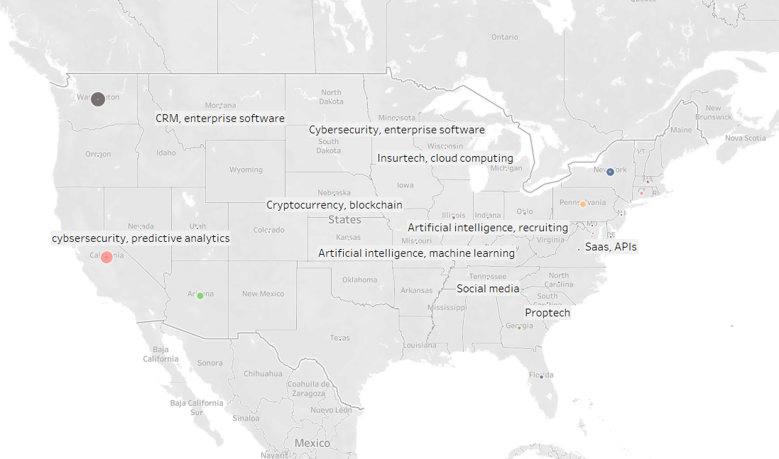

This graph shows the industries that dominated the layoff count across the United States. In California, cybersecurity and predictive analytics, and in Washington, E-commerce and SaaS, held the highest layoffs for industries in all 50 states.

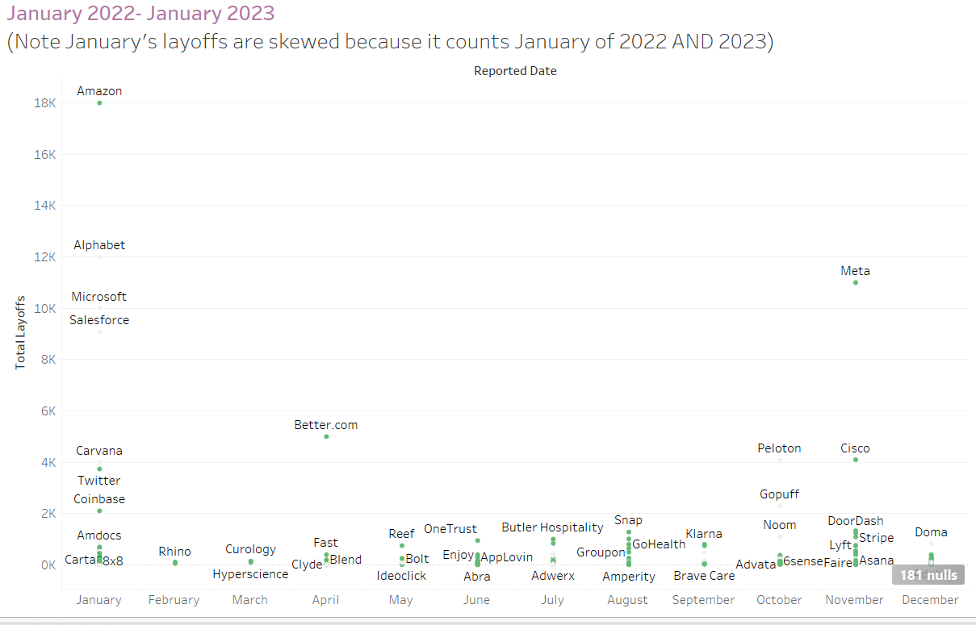

A line graph from January 2022-2023 is shown above to portray the layoff cycle that occurred in one year. January held the month with the highest layoffs and November came second with Meta leading the way. February had one of the lowest layoff months due to the month before the drastic layoff streak.

This map includes the states with a number of company layoff counts in each. California had the highest with New York coming in second. This shows how widely spread these layoffs were and how impacted America is. 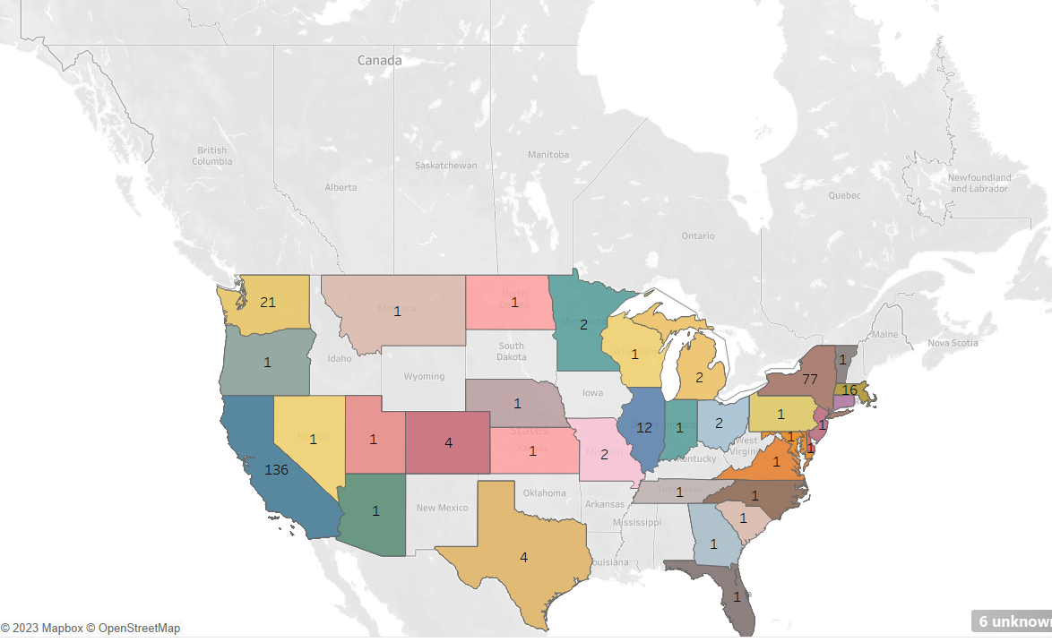

Uniphore had the highest impacted workforce percentage with a 76%, and then Parler and Mojo Vision tied second with 75%. The total amount of layoffs eliminating the unclear was 138,156.

# Conclusion

In conclusion, the recent wave of tech layoffs has had a significant impact on the workforce. While the tech industry continues to thrive, it is important to consider the human toll of these layoffs and explore ways to provide support and assistance to those who have been affected. Moving forward, it will be important for companies to balance their economic success with the well-being of their employees and the wider community. Public companies suffered major losses compared to private and Fintechs industry suffered the highest layoff count.

Fun fact! While this specific dataset does not include information on Tableau…

Tableau Software is also undergoing a major layoff since its parent company Salesforce.com Inc. said there would be companywide workforce and real estate cuts. Salesforce, which acquired Seattle-based Tableau in 2019, is laying off 10% of its 73,000-employee workforce.